MAY JUNE 2019
Part – A
- a) Define the asymptotic notions: Big-Oh, Big-Omega, Theta
Ans – i) Big-Oh: The function f(n)=O(g(n)) iff there exists positive constants c and n0 such that f(n)<=c*g(n) for all n, n>=n0. It represents the upper bound of the algorithm’s running time. It gives the longest amount of time taken for the algorithm to complete. E.g: Consider f(n)=2n+2 and g(n)=$n^{2}$.
f(n) <= c.g(n)
2n+2<=c$n^{2}$
2n+2<=c when n=1
N | F(n) | G(n)=$n^{2}$
2 | 6 | 4
3 | 8 | 9
4 | 10 | 16
5 | 12 | 25
6 | 14 | 36
Hence, we conclude that when c=1 and n>2, we obtain f(n) =O(g(n))

ii) Big Omega: The function f(n)=Ω(g(n)) iff there exists positive constants c and n0 such that f(n)>=c*g(n) for all n, n>n0. It represents the lower bound of an algorithm’s running time. It gives us the shortest amount of time taken by the algorithm. Eg: Consider f(n)=3n+2, let g(n)=n and c1=3
N | F(n) | c.g(n)
1 | 5 | 3
2 | 8 | 6
3 | 11 | 9
4 | 14 | 12
5 | 17 | 15
Hence, we conclude that when c=3 and n>0, we obtain f(n) = Ω(g(n))

iii) Theta: The function f(n)=Ɵ(g(n)) iff there exists positive constants c and n0 such that c1g(n)<=f(n)<c2g(n) for all n, n>n0. It is more precise. Eg: Consider f(n)=3n+2 and g(n)=n
Upper bound c2=4
N=1 f(n)=5 c2.g(n)=4
Lower bound c1=3
N=1 f(n)=5 c1.g(n)=3
Hence, we conclude that c1g(n)<=f(n)<c2g(n) holds true for the given functions.

b) Let S={a,b,c,d,e,f,g} be a collection of objects with benefit weight values as follows: a:(10,2), b:(5,3), c:(15,5), d:(7,7), e:(6,1), f:(18,4), g:(3,1). What is an optimal solution to the fractional knapsack for S assuming that the capacity of the knapsack is 15?
Ans -
 | a | b | c | d | e | f | g
P | 10 | 5 | 15 | 7 | 6 | 18 | 3
W | 2 | 3 | 5 | 7 | 1 | 4 | 1
P/W | 5 | 1.6 | 3 | 1 | 6 | 4.5 | 3
X | 1 | 2/3 | 1 | 0 | 1 | 1 | 1
Ʃxiwi=1*2+2/3*3+1*5+0*7+6*1+1*4+1*1=15
Ʃxipi=1*10+2/3*5+1*15+6*1+1*18+1*3=55.33
x = {1, 0.66, 1, 0, 1, 1, 1}
15-1=14
14-2=12
12-4=8
8-1=7
7-5=2
2-2=0

c) Explain how dynamic programming is applied to solve the travelling salesperson problem.
Ans- Given, directed weighted graph and edge length matrix.
Aim: Travel to vertex incurring minimum cost.
The travelling salesperson problem finds applications in following examples:
- routing postal van to pick up mail from mailboxes located at n different sites. Minimum cost will minimize the distance required.
- using a robot arm to tighten the nuts on some piece of machinery on an assembly line. A minimum cost tour will minimize the time needed for the arm to complete its task.
- A production environment in which several commodities are manufactured on the same set of machines. The manufacture proceeds in cycles.
Consider a tour with an edge (1,k) for some k Є V – {1} and a path from vertex k to vertex 1 goes through each vertex in V – {1,k}. Let g(i,S) be the shortest path starting at vertex I, going through all vertices in S and terminating at vertex 1. From the principle of optimality, it follows that:
G(1, V-{1})=$\min_{2≤k≤n}${$c_{1k}$+g(k, V-{1,k})}
Generalizing we obtain,
G(i,S})=$\min_{jЄS}${$c_{1k}$+g(j, S-{j})}

d) Write the algorithm to find Hamiltonian cycles using the backtracking algorithm.
Ans –
Algorithm NextValue(k)
//x[1:k-1] is a path of k-1 distinct vertices. If x[k]=0, then no vertex has yet been assigned to x[k]. After execution, x[k] is assigned to the next highest numbered vertex which does not already appear in x[1:k-1] and is connected by an edge to x[k-1]. Otherwise x[k]=0. If k=n, then in addition x[k] is connected to x[1].
{
repeat
{
x[k]:=(x[k]+1)mod(n+1); //next vertex
if(x[k]=0) then return;
if(G[x[k-1], x[k]]≠0) then
{ //Is there an edge?
for j:=1 to k-1 do if (x[j]=x[k]) then break;
//Check for distinctness
If(j=k) then //if true, then the vertex is distinct.
if(k<n) or ((k=n) and G[x[n], x[1]]≠0))
then return;
}
} until (false);
}
Algorithm Hamiltonian(k)
//This algorithm uses the recursive formulation of backtracking to find all the Hamiltonian cycles of a graph. The graph is stored as adjacency matrix G[1:n, 1:n]. All cycles begin at node 1.
{
repeat
{ //Generate values for x[k]
NextValue(k); //Assign a legal next value to x[k]
If(x[k]=0) then return;
If(k=n) then write (x[1:n]);
Else Hamiltonian(k+1);
} until(false);
}

- a) Describe the divide-and-conquer technique with a control abstraction.
Ans – Given a function to compute on n inputs the divide-and-conquer strategy suggests splitting the input inputs into k distinct subsets, 1<k<=n, yielding, k subproblems. These subproblems must be solved and then a method must be found to combine subsolutions into a solution of the whole. If the subsolutions are still relatively large, then the divide-and-conquer strategy van be reapplied. This can be written using a control abstraction. By control abstraction, we mean a procedure whose flow of control is clear but whose primary operations are specified by other procedures whose precise meanings are left undefined. It is given as:
Algorithm DAndC(P)
{
if Small(P) then return S(P);
else
{
Divide P into smaller instances P1, P2,… ,Pk, k>=1;
Apply DAndC to each of these subproblems;
return Combine(DAndC(P1), DAndC(P2),….,DAndC(Pk));
}
}
Explanation: DAndC is initially invoked as DAndC(P), where P is the problem to be solved. Small(P) is a Boolean-valued function that determines whether the input size is small enough that the answer can be computed without splitting. If this is so, the function S is invoked. Otherwise the problem P is divided into smaller subproblems. These subproblems P1, P2, …. , Pk are solved by recursive applications of DAndC. Combine is a function that determines the solution to P using the solutions to the k subproblems. Computing time,
T(n) = | g(n) n small
| T(n1) + T(n2) + …. + T(nk) + f(n) otherwise
Complexity,
T(n) = | T(1) n=1
| aT(n/b) + f(n) n>1

b) Draw a state-space tree for the given sum of subsets problem S={3,4,5,6} and m=13, for the fixed size tuple representation.
Ans – State space tree

Solution ={x1,x2,x4} = {3,4,6}

c) State the master theorem for solving recurrences.
Ans – The master’s theorem provides a cookbook method for solving recurrences of the form
T(n)=aT(n/b​)+f(n),
Where a represents the number of children each node has, and the runtime of each of the three initial nodes is the runtime of T(n/b). The tree has a depth of $\log_{b}^{n}$ and depth I contains $a^{i}$ nodes. So there are $a^{\log_{b}^{n}}$ = $n^{\log_{b}^{a}}$ leaves and hence the runtime is Ɵ( $n^{\log_{b}^{a}}$).
for constants a≥1 and b>1 with f(n) asymptotically positive, the following statements are true:
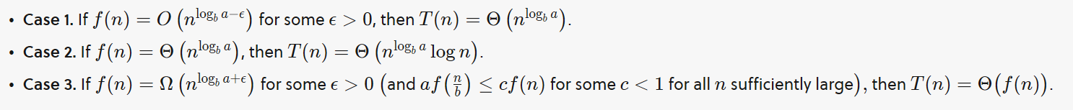
To use the master’s theorem, we simply determine or calculate the value $n^{\log_{b}^{a}}$ and compose it with f(n) to determine which case of the master’s theorem applies to it. Simply put, if f(n) is polynomially smaller than $n^{\log_{b}^{a}}$ , then $n^{\log_{b}^{a}}$ dominates, and the runtime is Ɵ($n^{\log_{b}^{a}}$). If f(n) is instead polynomially larger than $n^{\log_{b}^{a}}$, then f(n) dominates, and the runtime is Ɵ(f(n)). Finally, if they are asymptotically same, then T(n)=Ɵ($n^{\log_{b}^{a}}$log n)

d) Explain the graph colouring problem. How is it solved using backtracking?
Ans – Let G be a graph and m be a given positive integer. Aim: To discover whether the nodes of G can be coloured in such a way that no 2 adjacent nodes have the same colour yet only m colours are used. This is termed as m-colorability decision problem. If d is the degree of the graph, then it can be coloured with d+1 colours. Suppose we represent a graph by its adjacency matrix G[1:n, 1:n], where G[I,j]=1 if (i,j) is an edge of G and G[i,j]= 0 otherwise. The colours are represented by integers 1,2,.., m and the solutions are given by the n-tuple (x1,x2,…,xn), where xi is the colour of node i. We use the recursive backtracking algorithm to solve this. The underlying space state tree is a tree of degree m and height n+1. Each node at level I has m children corresponding to the m possible assignments to xi, 1<=i<=n. Nodes at level n+1 are lead nodes. Function mColoring is begun by first assigning the graph to its adjacency matrix, setting the array x[] to xero, and the invoking the statement mColoring(1);. Function NextValue produces the possible colours of xk after x1 through $x_{k-1}$ have been defined. The main loop of mColoring repeatedly picks an element from the set of possibilities, assigns it to xk and then calls mColoring recursively. Consider the following example:

Algorithm mColoring(k)
//This algorithm was formed using the recursive backtracking schema. The graph is represented by its Boolean adjacency matrix G[1:n,1:n]. All assignments of 1,2,..,m to the vertices of the graph such that adjacent vertices are assigned distinct integers are printed. K is the index of the next vertex to color.
{
repeat
{ //Generate all legal assignments for x[k]
NextValue(k); //Assign to x[k] a legal colour
if(x[k]=0) then return; //No new colour possible
if(k=n) then //at most m colors have been used to color the n vertices
write(x[1:n]);
else mColoring(k+1);
} until(false);
}

Algorithm NextValue(k)
//x[1],…,x[k-1] have been assigned integer values in the range [1,m] such that adjacent vertices have distinct integers. A value for x[k] is determined in the range [0,m]. x[k] is assigned the next highest numbered color while maintaining distinctness from the adjacent vertices of vertex k. If no such colour exists, them x[k] is 0.
{
repeat
{
x[k]:= (x[k]+1) mod(m+1); //Next highest colour
if(x[k]=0) then return; //All colors have been used
for j:=1 to n do
{ // Check if this color is distinct from adjacent colors
if((G[k,j]≠0) and (x[k]=x[j])
//If (k,j) is an edge and if adjacent vertices have same color
then break;
}
if(j=n+1) then return; //New color found
}until(false);
}

- a) Write an iterative algorithm to find the maximum and minimum items in a set of n elements. Transform your iterative algorithm into an equivalent algorithm that uses recursion. Compare the efficiency of both the algorithms and show which one is powerful.
Ans – Iterative Approach:
Algorithm StraightMaxMin(a, n, max, min)
{
max := min := a[1];
for i :=2 to n do
{
if (a[i] > max) then max :=a [i];
if (a[i] < min) then min :=a [i];
}
}
The number of comparisons in iterative method is 2n - 2.

Recursive Approach:
Algorithm MaxMin(i, j, max, min)
{
if (i = j) then max := min := a[i];
else if (i = j - 1) then
{
if (a[i] < a[j]) then
{
max := a[j]; min := a[i];
}
else
{
max := a[i]; min := a[j];
}
}
else
{
mid:=[(i + j)/2];
MaxMin(i, mid, max, min);
MaxMin(mid + 1, j, max1, min1);
if (max < max1) then max := max1;
if (min > min1) then min := min1;
}
}
The number of comparisons in recursive method is 3n/2 – 2. Hence recursive method is better than iterative.

b) Draw the solution space tree using backtracking for 4 Queen’s problem.
Ans – 4 queens are to be placed on a 4x4 chessboard so that no 2 attack, that is, no 2 queens are on the same row, column or diagonal. The solution space consists of n!=4!=24 Leaf nodes (solutions) of the n-tuple(1,2,3,4).

c) Explain the branch and bound technique.
Ans – The term branch and bound refers to all state space search methods in which all the children of the E-node are generated before any other live node can become the E-node. In this, a BFS-like state space search tree is called FIFO and D-Search state space search will be called LIFO. Bounding functions are used to help avoid the generation of subtrees that do not contain an answer node. This algorithm is generally used for solving combinatorial optimization problems. These problems are typically exponential in terms of time complexity and may require exploring all possible permutations in worst case. The Branch and Bound Algorithm technique solves these problems relatively quickly.

Let’s see the Branch and Bound Approach to solve the 0/1 Knapsack problem: The Backtracking Solution can be optimized if we know a bound on best possible solution subtree rooted with every node. If the best in subtree is worse than current best, we can simply ignore this node and its subtrees. So we compute bound (best solution) for every node and compare the bound with current best solution before exploring the node. Example bounds used in below diagram are, A down can give $315, B down can $275, C down can $225, D down can $125 and E down can $30.
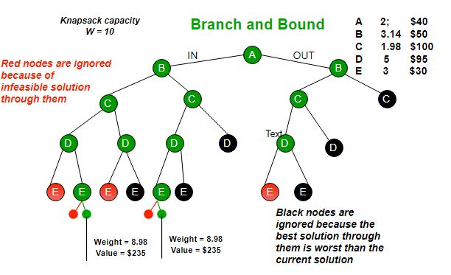
PART B
- a) What is a compressed trie? State its properties.
Ans – A compressed trie is similar to a standard trie but it ensures that each internal node in the trie has at least 2 children. It enforces this rule by compressing chains of single-child nodes into individual edges. Let T be a standard trie. We say that an internal node v of T is redundant if v has one child and is not the root. Let us also say that a chain of k>= 2 edges, (v0,v1)(v1,v2)….($v_{k-1}$,vk) is redundant if
+ vi is redundant for i=1,..,k-1
+ v0 and vk are not redundant
We can transform T into a compressed trie by replacing each redundant chain (v0,v1)(v1,v2)….($v_{k-1}$,vk) of k>=2 edges into a single edge (v0, vk), relabeling vk with the concatenation of the labels of nodes v1,…,vk.
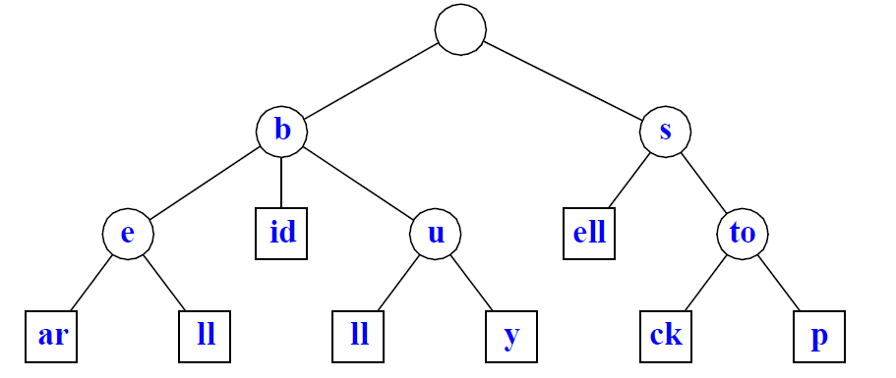
Properties of compressed trie storing a collection S of s strings from an alphabet of size d :
- Every internal node of T has at least 2 children and at most d children.
- T has s external nodes.
- The number of nodes of T is O(s).

b) Explain how the Euler-tour technique is applied to compute the depth of each node in an n-node binary tree using the parallel model.
Ans – A Euler tour of a graph is a cycle that traverses each edge exactly once, although it may visit a vertex more than once. A connected, directed graph has a Euler tour iff for all vertices v, the in-degree of v equals the out-degree of v. Since each undirected edge(u,v) in an undirected graph maps to two directed edges (u,v) and (v,u) in the directed version, the directed version of any connected, undirected graph – and therefore of any undirected tree – has a Euler tour. To compute the depths of nodes in a binary tree T, we first form a Euler tour of the directed version of T (viewed as an undirected graph). Structure is as follows:
- A node’s A processor points to the A processor of its left child, if it exists and otherwise to its own B processor.
- A node’s B processor points to the A processor of its right child, if it exists, and otherwise to its own C processor.
- A’s node C processor points to the B processor of its parent if it is a left child and to the C processor of its parent if it is a right child. The root’s C processor points to NIL.
The head of the linked list formed by the Euler tour is the root’s A processor, and the tail is the root’s C processor. Given the pointers composing the original tree, an Euler tour can be constructed in O(1) time. Once we have the linked list representing the Euler tour of T, we place a 1 in each A processor, a 0 in each B processor, and a -1 in each C processor. We then perform a parallel prefix computation using ordinary addition as the associative operation. The numbers are placed into the A, B and C processors in such a way that the net effect of visiting a subtree is to add 0 to the running sum. The A processor of each node i contributes 1 to the running sum in i’s left subtree. The B processor contributes 0 because the depth of node i’s left child equals the depth of node i's right child. The C processor contributes -1, so that from the perspective of node i's parent, the entire visit to the subtree routed at node i has no effect on the running sum.

c) Write the non-deterministic algorithm for the knapsack decision problem.
Ans- Lines 1 to 3 assign 0/1 values to X(), 1<=i<=n. Line 4 checks to see if the assignment is feasible and if the resulting profit is at least R. A successful termination is possible if and only if the answer to the decision problem is yes. The time complexity is O(n). If m is the input length using a binary representation, the time is O(m).
Algorithm DKP(p, w, n, m, r, x)
{
W:=0;
P:=0;
for i:=1 to n dp
{
x[i]:=Choice(0,1);
W:=W+x[i]*w[i];
P:=P+x[i]*p[i];
}
if((W>m) or (P<r)) then Failure();
else Success();
}

d) Explain the operation of the approximation algorithm for the vertexcover problem of the given graph.

Ans – C = φ
E = {(1, 2), (2, 3), (3, 4), (3, 5), (4, 5), (4, 6), (5, 6), (4, 7)}

Consider arbitrary edge chosen is (2, 3).
C = φ υ {2, 3} = {2, 3}
Removing edges (1, 2), (3, 5) and (3, 4) from E, we get,
E = {(4, 5), (4, 6), (5, 6), (4, 7)}

Consider arbitrary edge chosen is (5, 6).
C = {2, 3} υ {5, 6} = {2, 3, 5, 6}
Removing edges (4, 5), (4, 6) from E, we get,
E = {(4, 7)}

Edge chosen is (4, 7).
C = {2, 3, 5, 6} υ {4, 7} = {2, 3, 5, 6, 4, 7}
E = φ
Using Approximation algorithm, all edges were covered using C.

- a) Write a CRCW algorithm for finding the maximum of n values in an array. Is it work efficient?
Ans – The CRCW algorithm that finds the maximum of n array elements assumes that the input array is A[0…n-1]. The algorithm uses $n^{2}$ processors with each processor comparing A[i] and A[j] for some i and j in the range 0<=I, j<=n-1. In effect, the algorithm performs a matrix of comparisons, and so we can view each of the $n^{2}$ processors as not only having a one-dimensional index in the PRAM, but also a two-dimensional index (i,j).
FAST-MAX(A)
n<-length(A)
for i<-0 to n-1, in parallel
do m[i] <- TRUE
for i<-0 to n-1 and j<-0 to n-1, in parallel
do if A[i]<A[j}
then m[i]<- FALSE
for i<-0 to n-1 , in parallel
do if m[i]=TRUE
then max<-A[i]
return max

Line 1 simply determines the length of the array A; it only needs to be executed on one processor, say processor 0. We use an array m[0..n-1], where processor i is responsible for m[i]. We want m[i] = TRUE if and only if A[i] is the maximum value in the array A. We start lines 2-3 by believing that each array element is possibly the maximum and we rely on comparisons in line 5 to determine which array elements are not the maximum.
 | 5 | 6 | 9 | 2 | 9 | m[i]
5 | F | T | T | F | T | F
6 | F | F | T | F | T | F
9 | F | F | F | F | F | T
2 | T | T | T | F | T | F
9 | F | F | F | F | F | T
 |  |  |  |  | max | 9
Figure illustrates the remainder of the algorithm. In the loop of lines 4-6, we check each ordered pair of elements of array A. For each pair A[i] and A[j], line 5 checks whether A[i]<A[j]. If the comparison is TRUE, we know that A[i] cannot be maximum, and line 6 sets m[i]<- FALSE to record this fact. Several (i,j) pairs may be writing to m[i] simultaneously, but they all write the same value: FALSE.
It is not work-efficient, since it consists of 3 loops and requires n² processors, and the problem of finding the maximum number in an array can be solved by a (n)-time serial algorithm.

b) How can a Monte Carlo algorithm be used to verify matrix multiplication? Explain.
Ans – Freivalds' algorithm is a probabilistic randomized algorithm used to verify matrix multiplication. It is a randomized Monte Carlo algorithm and has a small probability of error. Given three n x n matrices, Freivalds' algorithm determines in O(kn^2) whether the matrices are equal for a chosen k value with a probability of failure less than 2^-k.

Algorithm:

Input: n×n matrices A, B and C.

We would like to verify if A×B=C.
Choose a n×1 column vector r→∈{0,1}n, uniformly and at random. In other words, each component of the vector is either 0 or 1 and chosen randomly and uniformly.

Compute A⋅(B⋅r) and C⋅r. This takes Θ(n^2) time.

Now comes the output.
If A⋅(B⋅r)≠C⋅r, output FALSE. In other words, we say that the given matrix multiplication is incorrect. This has a probability of correctness = 1.
If A⋅(B⋅r)=C⋅r, output TRUE. In other words, we say that the given matrix multiplication is correct. This has a probability of correctness ≥1/2.

c) Discuss the satisfiability problem and its non-deterministic solution.
Ans – Let x1, x2, … denote Boolean variables (their value is either true or false). Let $\overline{xi}$ denote the negation of xi. A literal is either a variable or its negation. A formula in the proportional calculus is an expression that can be constructed using literals and the operations and and or. Satisfiability problem is to determine whether a formula is true for some assignment of truth values to the variables. CNF satisfiability is the satisfiability problem for CNF formulas.
Time proportional to length of E. : O(n)
Algorithm Eval(E, n)
//Determine whether the propositional formula E is satisfiable. The variables are x1, x2, .. xn.
{
for i:=1 to n do //Choose a truth value assignment
xi:= Choice(false, true);
if E(x1, …., xn) then Success();
else Failure();
}

d) Write the approximation algorithm for the set-covering problem.
Ans – Algorithm: GREEDY-SET-COVER(X,F)
U<-X
C<-ф
while U≠ф
do select an S Є F that maximizes |S ∩ U|
U<-U-S
C<-C ∪ {S}
return C

- a) Discuss the different categories of probabilistic algorithms.
Ans – There is a variety of behaviours associated with probabilistic algorithms:
1. Monte Carlo algorithms
2. Las Vegas algorithms
3. Sherwood algorithms
4. Numerical Approximation algorithms
1. Monte Carlo algorithms
* Algorithms which always return a result, but the result may not always be correct. Attempt to minimize the probability of an incorrect result, and using the random element, multiple runs of the algorithm will reduce the probability of incorrect results.
* These are called Monte Carlo algorithms. Example: Primality testing
2. Las Vegas algorithms
* Algorithms that never return an incorrect result, but may not produce results at all on some runs. To minimize the probability of no result, and because of the random element, multiple runs will reduce the probability of no result. These are called Las Vegas algorithms.
* Example: factoring
3. Sherwood algorithms
* Algorithms which always return a result and the correct result, but where a random element increases the efficiency, by avoiding or reducing the probability of worst-case behaviour.
* Useful for algorithms which have a poor worst-case behaviour but a good average-case behaviour. These are called Sherwood algorithms
Example: Quicksort
4. Numerical Approximation algorithms
* Here the random element allows us to get approximate numerical results, often much faster than direct methods, and multiple runs will provide increasing approximation.

b) Compute a table representing the KMP failure function for the pattern string CGTACGTTCGTAC.
Ans –
C G T A C G T T C G T A C
1 2 3 4 5 6 7 8 9 10 11 12 13
0 0 0 0 1 2 3 0 1 2 3 4 1
0 1 2 3 4 5 6 7 8 9 10 11 12

c) Elucidate the commonly believed relationship between class P, NP, NP-complete and NP-hard problem.
Ans – A problem / language B is NP-complete if it satisfies the following two conditions:
1. The problem B is in Class NP
2. Every problem A in NP is reducible to B in polynomial time.
If a problem or a language satisfies the second property, but not necessarily the first one, then the problem / language B is known as NP-Hard.
Informally, a search problem B is NP-Hard if there exists some NP-Complete problem A that reduces to B.
§ The problem in NP-Hard cannot be solved in polynomial time, until P = NP. If a problem is proved to be NP-Complete, there is no need to waste time on trying to find an efficient algorithm for it. Instead, we can focus on design approximation algorithm.

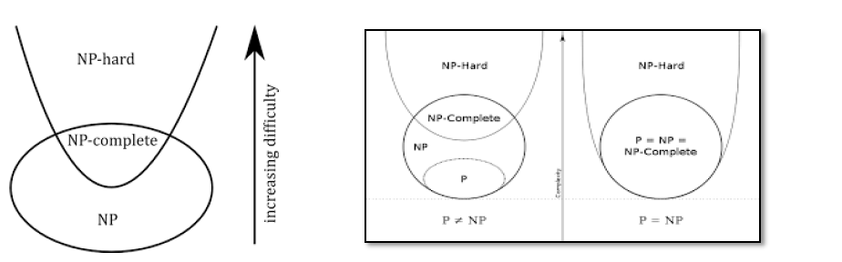

d) What are the performance bounds for approximation algorithm.
Ans – Let P be a minimization problem and I be an instance of P.
§ Let A be an algorithm that finds feasible solution to instances of P.
§ Let A(I) is the cost of the solution returned by A for instance I and OPT(I) is the cost of the optimal solution for I. Then, A is said to be an α-approximation algorithm for P if,
I, ≤ , where α ≥ 1.
§ So any minimum optimization problem A(I) ≥ OPT(I). Therefore, 1-approximation algorithm produces an optimal solution.
§ An approximation algorithm with a large α may return a solution that is much worse than optimal. So the smaller α is, the better quality of the approximation the algorithm produces.
For instance size n, the most common approximation classes are:
a. α = O(n c ) for c < 1, e.g. Clique.
b. α = O(log n), e.g. Set Cover.
c. α = O(1), e.g. Vertex Cover.

PART C
- a) Given a set of n jobs. Associated with each job k is a deadline dk and profit pk. For any job k the profit pk is earned iff the job is completed by its deadline dk. Formulate a greedy algorithm to obtain an optimal solution for this problem. State its time complexity.
Ans – Algorithm JS(d,j,n)
// d[i] >= 1, 1<=i<=n are the deadlines, n>= 1.The jobs are ordered such that
// p[1]>=p[2]….>=p[n]. J[i] is the ith job in the optimal solution, 1<=i<=k. Also,
// at termination d[J[i]]<=d[J[i+1]], 1 <=i<k.
{
D[0] := J[0] := 0; // Initialise
J[1] := 1;
k:= 1
For i:= 2 to n do
{
R:=k;
While ((d[J[r]] > d[i] and (d[J[r]] != r )) do r:= r-1;
If ((d[J[r]] <= d[i] ) and d[i] > r )) then
{
//Insert I into J[]
For q:= k to (r+1) step – 1 do J[q+1] :=J[q];
J[r+1]:=I;
K:=k+1;
}
return k;
}

Time complexity
Sort job according to decreasing order of deadlines = O(nlogn)
For each job find slot in array of size n = O(n^2)
So time complexity = O(nlogn) + O(n^2) = O(n^2)

b) Write the general iterative backtracking algorithm.
Ans – Algorithm IBacktrack(n)
//This schema describes the backtracking process.
//All solutions are generated in x[1 : n] and printed as soon as they are determined.
{
K := 1;
While (k ≠ 0) do
{
If (there remains an untried x[k] € T(x[1],x[2],…….,x[k-1]) and B_{k}(x[1],….,x[k]) is true) then
{
If (x[1],…,x[k] is a path to an answer node)
then write (x[1 : k]);
k := k + 1; // Consider the next set.
}
else k := k - 1; // Backtrack to the previous set.
}
}

c) Determine the longest common subsequence (LCS) between the 2 strings: X=”CBAF”, Y=”ABCDBACDF”. Write the method do construct the LCS.
Ans – Longest common sub sequence is “CBAF”
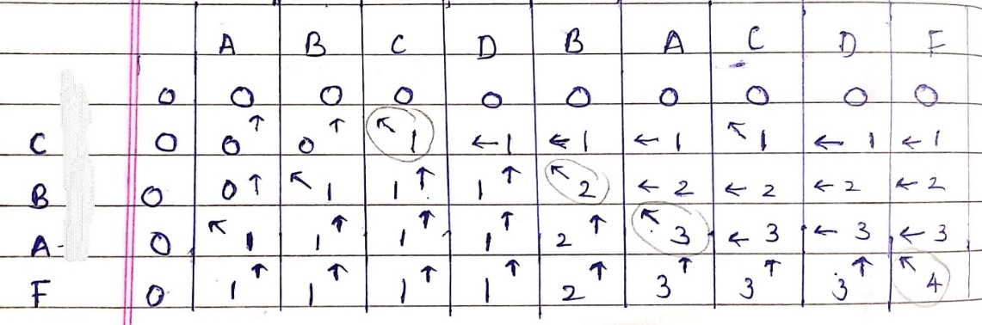

Method to construct the LCS
1. Start from L [n - 1, m - 1] and work back through the table, reconstructing a longest common subsequence from back to front.
2. At any position L[i, j],
3. if X [i] = Y [j] then
Take X [i] as the next character of the subsequence
Move next to L [i - 1, j - 1] .
4. If X *i+ ≠ Y [j] then
Move to the larger of L[i, j - 1 ] and L[i - 1, j].
5. Stop when a boundary entry is reached (with i = -1 or j = -1).

d) When are the probabilistic algorithms preferred? What are their characteristics?
Ans – Probabilistic algorithms are preferred in
1. In some applications the use of probabilistic algorithms is natural, e.g. simulating the behaviour of some existing or planned system over time. In this case the result by nature is stochastic.
2. In some cases the problem to be solved is deterministic but can be be transformed into a stochastic one and solved by applying a probabilistic algorithm (eg. Numerical integration, optimization).
3. For these numerical applications the result obtained is always approximate, but its expected precision improves as the time available to use the algorithm increases.
4. There are also a number of discrete problems for which only an exact result is acceptable (eg. sorting and searching) and where the introduction of randomness influences only on the ease and efficiency in finding the solution.
5. For some problems where trivial exhaustive search is not feasible probabilistic algorithms can be applied giving a result that is correct with a probability less than one (eg. primality testing, string equality testing).
6. The probability of failure can be made arbitrary small by repeated applications of the algorithm.
7. One incentive for using probabilistic algorithms is that their application does not normally require sophisticated mathematical knowledge. Further, the programming is often rather trivial which means that an acceptable approximation can be obtained quickly.
8. One can say that the use of probabilistic algorithms sometimes allow that theoretical knowledge and analytical work is compensated for by making extensive simple machine computations.
9. In some other cases the probabilistic algorithms are the simplest and even the most efficient available and for some problems no other feasible algorithm is known to exist (eg. primality testing).
Characteristics of Probabilistic Algorithms are
- At least once during the algorithm, a random number is used to make a decision instead of spending time to work out which alternative is best.
- The worst-case running time of a randomized algorithm is almost always the same as the worst-case running time of the non-randomized algorithm.
- A probabilistic algorithm A is good if it is efficient and if, say, for every x,
Pr_{r} [A(x,r) = correct answer for x) ≥ ¾
- A probabilistic algorithm runs quickly but occasionally makes an error. The probability of error can, however, be make negligibly small.
- Any purported solution can be verified efficiently for correctness. This algorithm may give probabilistic answers which are not necessarily exact.
- The same algorithm may behave differently when it is applied twice to the same instance. Its execution time, and even the result obtained, may vary considerable from one use to the next.
- If the algorithm gets stuck (e.g., core dump), simply restart it on the same instance for a fresh chance of success.
- If there is more than one correct answer, several different ones may be obtained by running the probabilistic algorithm more than once. An expected running time bound is somewhat stronger than an average-case bound, but is weaker than the corresponding worst-case bound.

- a) Write an algorithm that takes the positive integer ‘n’ as input and returns the exponent $2^{n}$ as output. Analyze the time complexity of your algorithm using program step table method.
Ans –
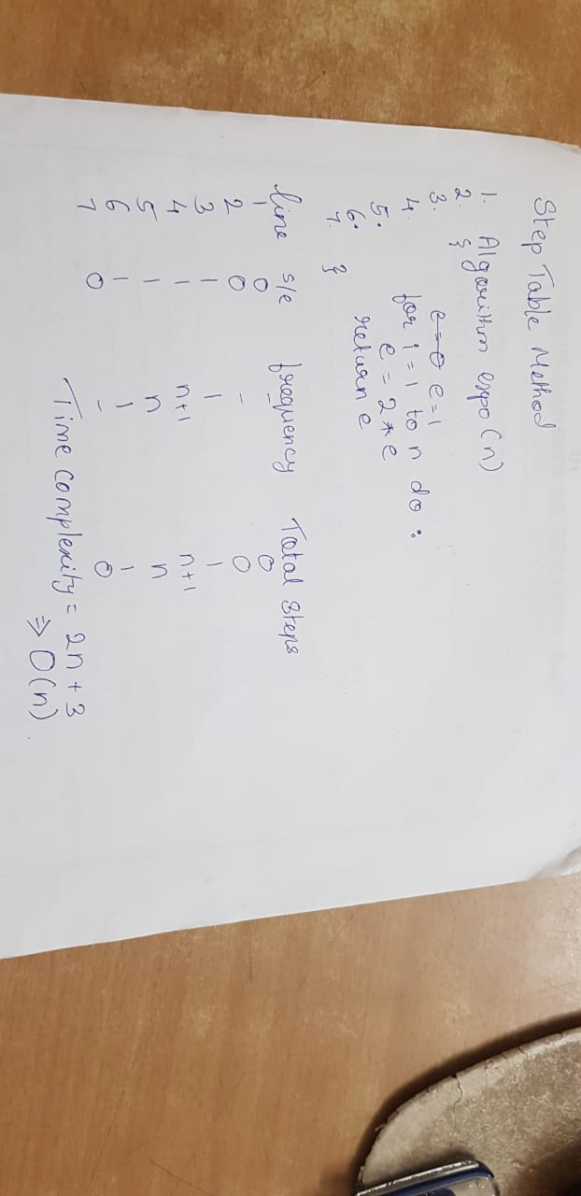

b) State the principle of optimality.
Ans – The principle of optimality is the basic principle of dynamic programming, which was developed by Richard Bellman: that an optimal path has the property that whatever the initial conditions and control variables (choices) over some initial period, the control (or decision variables) chosen over the remaining period must be optimal for the remaining problem, with the state resulting from the early decisions taken to be the initial condition.

c) What is the strategy to show that a problem L2 is NP-hard?
Ans – The strategy we adopt to show a problem L2 is NP-hard is:
1)Pick a problem L1 that is NP-hard.
2)Show how to obtain an instance I¹ of L2 from any instance I of L1 such that from the solution of I¹ we can determine the solution to instance I of L1.
3) Conclude from step2 that L1 α L2
4) conclude from steps 1 and 3 and transitivity that L2 is NP-hard. 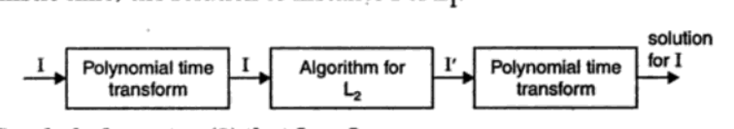

d) Explain how an approximation algorithm can be used to solve the travelling salesperson problem.
Ans – Problem Description:
A salesman wants to visit each of n cities exactly once each, minimizing total distance travelled and returning to the starting point.
Input: A complete undirected graph G = (V,E), with edge weights (costs) w, and |V| = n.
Output: A tour (cycle that visits all n vertices exactly once and returning to starting vertex) of minimum cost.
Approximation Algorithm for metric TSP
A metric space is a pair (S, d), where S is a set and d is a distance function that satisfies, for all u, v, w S, the following conditions.
1. d (u, v) = d (v, u)
2. d (u, v) + d(v, w) ≥ d (u, w) (triangle inequality – a least distance to reach a vertex w from vertex u is always to reach w directly from u, rather than through some other vertex v).

The approximation algorithm works only if the problem instance satisfies Triangle – Inequality. Algorithm APPROX – TSP - TOUR (G)
1. Select a starting vertex r V, to be a root vertex.
2. Compute a weighted MST T for G from r.
3. Traverse the MST T, in pre-order: v1, v2, . . . , vn.
4. Return tour: v1 v2 · · · vn v1.

NOV-DEC 2019
Part – A
- a) What are the criteria for designing an efficient algorithm?
Ans - All algorithms must satisfy the following criteria:
1)input-zero or more quantities are externally supplied.
2)output-at least one quantity is produced.
3)definiteness-each instruction is clear and unambiguous.
4)finiteness-if we trace out the instructions of an algorithm, then for all cases the algorithm terminates after a finite number of steps
5)effectiveness-every instruction must be very basic so that it can be carried out, in principle, by a person using only pencil and paper.it is not enough that each operation be definite as in criterion 3; it also must be feasible.

b) Let ai, 1<=i<=n, be a list of elements that are sorted in non-decreasing order. Devise a suitable algorithm to determine whether a given element c is present in the list by using divide and conquer strategy.
Ans - Algorithm Binary-Search (A[0..N-1], value, low, high)
//Input: An Array A [1..n] has elements are ordered & the element value.
//Output: Return the position of the element value, if found in the array.
if high < low then
mid = low +(high – low) / 2)
if A[mid] =value then return mid;
else if A[mid] > value then
return Binary-Search (A, value, low, mid-1)
else return Binary-Search(A, value, mid+1, high)
else return -1;

c) Consider the graph G=(V,E) where V=(1,2,3,4) and the edge length are given by a matrix below. Find the optimal tour of the graph starting from vertex 1 using Dynamic programming.
0 | 12 | 5 | 7
11 | 0 | 13 | 6
4 | 9 | 0 | 18
10 | 3 | 2 | 0
Dynamic Programming : Travelling Salesman
starting Vertex k=1

Step 1: k = 1, for NULL set,
g(2,NULL ) = c21 = 11
g(3, NULL) = c31 = 4
g(4, NULL) = c41 = 10

Step 2: K=1, for sets of size 1
Set {2}:
g(3,{2}) = c32 + g(2,NULL ) = c32 + c21 = 9 + 11 = 20 p(3,{2}) = 2
g(4,{2}) = c42 + g(2, NULL) = c42 + c21 = 3 + 11 = 14 p(4,{2}) = 2
Set {3}:
g(2,{3}) = c23 + g(3, NULL ) = c23 + c31 = 13 + 4 = 17 p(2,{3}) = 3
g(4,{3}) = c43 + g(3, NULL ) = c43 + c31 = 2 + 4 = 6 p(4,{3}) = 3
Set {4}:
g(2,{4}) = c24 + g(4, NULL ) = c24 + c41 = 6 + 10 = 16 p(2,{4}) = 4
g(3,{4}) = c34 + g(4, NULL ) = c34 + c41 = 18 + 10 = 28 p(3,{4}) = 4

Step 3: K=2, for sets of size 2
Set {2,3}:
g(4,{2,3}) = min {c42 + g(2,{3}), c43 + g(3,{2})} = min {3+17, 2+20}= min {20, 22}= 20 p(4,{2,3}) = 2
Set {2,4}:
g(3,{2,4}) = min{c32 + g(2,{4}), c34 + g(4,{2})} = min{9+16,18+14}= min{25,32} = 25 p(3,{2,4}) = 2
Set {3,4}:
g(2,{3,4}) = min {c23 + g(3,{4}), c24 + g(4,{3})} = min {13+28, 6+6}= min {41, 12}= 12 p(2,{3,4}) = 4

Length of an optimal tour:
g(1,{2,3,4}) = min { c12 + g(2,{3,4}), c13 + g(3,{2,4}), c14 + g(4,{2,3}) }
= min {12 + 12, 5 + 25, 7 + 20}
= min {24, 30, 27}
= 24

Successor of node 1: p (1, {2, 3, 4}) = 2
Successor of node 3: p (2, {3, 4}) = 4
Successor of node 4: p (4, {3}) = 3
The optimal TSP tour reaches: 1 → 2 → 4 → 3 → 1

- a) Determine the subset of given set of items that fits into the binary knapsack of capacity units which gives maximum profit using dynamic programming formulation, n=4, the weights (w1,..,w4)=(2,5,8,1) and the profits (p1…p4)=(10,15,6,9)
 | Obj1 | Obj2 | Obj3 | Obj4
Profit | 10 | 15 | 6 | 9
Weight | 2 | 5 | 8 | 1
(1/0) knapsack: Either object is present completely or absent completely.
Capacity=7. Consider the set (p,w)
S⁰ = {(0, 0)} …no object in the bag
S⁰₁ = {(10, 2)}…obj1 is in the bag
S¹= {(0, 0), (10, 2)}…either obj1 is present or absent.
S¹₁= {(15, 5) , (25,7)}…obj2 is present or obj2 and obj1 are present.
S²={(0,0) ,(10,2) ,(15,5), (25,7)}.. empty or obj1 is present or obj2 is present or obj1 and obj2 are present.
Similarly,
S²₁={(6,8) ,(16,10),(21,13) ,(31,15) }
S³ ={(0,0) ,(10,2),(15,5),(25,7)}….since capacity =7 sets having weight greater than 7 are discarded.
S³₁= {(9,1),(19,3),(24,6),(34,8)}
S⁴={( 0,0) , (9,1), (10,2), (19,3), (24,6), (25,7)}…. Purging rule (increase in profit should result in increase in weight hence (15,5) is removed).
Consider the last tuple of S⁴ ie (25,7)
(25, 7) belongs to S⁴ and also belongs to S³ therefore obj4=0(absent).
(25, 7) belongs to S³ and belongs to S² therefore obj3=0(absent).
(25, 7) belongs to S² and does not belong to S¹ therefore obj2=1( present)
Consider ( 25 -15,7-5) =(10,2) belongs to S¹ and does not belong to S⁰ therefore obj1=1(present).
Therefore the solution subset is (1, 1, 0 ,0 ) and maximum profit is 10+15=25.

b) Discuss how the divide and conquer strategy is used to multiply 2 square matrices as suggested by Strassen. Illustrate by using the following matrices.
A= | 2 3 | B= | 4 3 |
| 3 2 | | 3 4 |
Ans : Following is simple Divide and Conquer method to multiply two square matrices.
1) Divide matrices A and B in 4 sub-matrices of size N/2 x N/2 as shown in the below diagram.
2) Calculate following values recursively. ae + bg, af + bh, ce + dg and cf + dh.
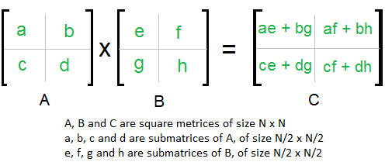
In the above method, we do 8 multiplications for matrices of size N/2 x N/2 and 4 additions.
In the divide and conquer method, the main component for high time complexity is 8 recursive calls. The idea of Strassen’s method is to reduce the number of recursive calls to 7. Strassen’s method is similar to above simple divide and conquer method in the sense that this method also divide matrices to sub-matrices of size N/2 x N/2 as shown in the above diagram, but in Strassen’s method, the four sub-matrices of result are calculated using following formulae.
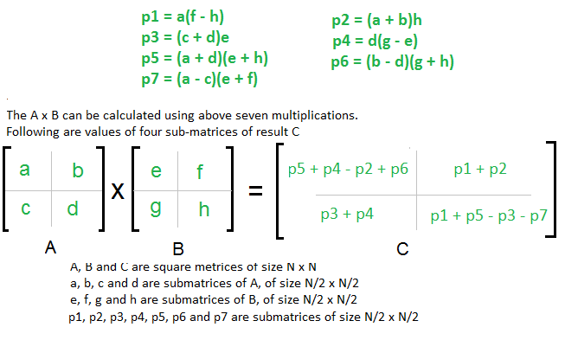
Illustration for A*B=C
C11= A11*B11 +A12*B21=2*4 + 3*3=15
C12=A11*B12 +A12*B22=18
C21=A21*B11 +A22*B21=15
C22=A21*B12 +A22*B22=18

c) Compare Greedy method and dynamic programming.
 | Greedy method | Dynamic programming
Feasibility: | In a greedy Algorithm, we make whatever choice seems best at the moment in the hope that it will lead to global optimal solution. | In Dynamic Programming we make decision at each step considering current problem and solution to previously solved sub problem to calculate optimal solution .
Optimality: | In Greedy Method, sometimes there is no such guarantee of getting Optimal Solution. | It is guaranteed that Dynamic Programming will generate an optimal solution as it generally considers all possible cases and then choose the best.
Recursion: | A greedy method follows the problem solving heuristic of making the locally optimal choice at each stage. | A Dynamic programming is an algorithmic technique which is usually based on a recurrent formula that uses some previously calculated states.
Memorization: | Greedy method is more efficient in terms of memory as it never look back or revise previous choices | Dynamic programming requires dp table for memorization and it increases it’s memory complexity.

- a) Let n=5, (p1,…,p5)=(20,10,15,1,5) and (d1…d5)=(2,2,1,3,3), obtain the optimal schedule that finishes the jobs by its deadline and given the maximum profit.
Ans - N=5
Jobs | J1 | J2 | J3 | J5 | J4
Profits | 20 | 15 | 10 | 5 | 1
Deadlines | 2 | 2 | 1 | 3 | 3

Job slot assignment solution profit
J1 [1,2] J1 20
J2 [0,1][1,2] J1,J2 or J2,J1 35
J3 [0,1][1,2] J1,J2 35(discarded due to deadline)
J5 [0,1][1,2][2,3] J1,J2,J5 40
J4 [0,1][1,2][2,3] J1,J2,J5 40(discarded due to deadline)
Thus the solution is the sequence of jobs (J1,J2,J5) or (J2,J1,J5),which are being executed within their deadline and gives maximum profit. Total profit of the sequence is 20+15+5=40.

b) Let n=4, (x1,x2,x3,x4)=(Bicholim, Dabolim, Panjim, Verna), p(1..4)=(3,3,1,1) and q(0..4)= (2,3,1,1,1). Construct an optimal binary search tree.
Ans - Equations:
w(i,i) = q(i) w(i,j)=p(j) +q(j) + w(i,j-1)
c(i,i) = 0 c(i,j) = min_{i<k<=j}{c(i,k-1) + c(k,j)} +w(i,j)
r(i,i) = 0 r(i,j) = k which gives minimum c(i,j)

w(0,1) = p(1) +q(1) +w{0,0} = 8
c(0,1) = w(0,1) +min {c(0,0) +c(1,1)} = 8
r(0,1) = 1

w(1,2) = p(2) +q(2) +w{1,1} = 7
c(1,2) = w(1,2) +min {c(1,1) +c(2,2)} = 7
r(1,2) = 2

w(2,3) = p(3) +q(3) +w{2,2} = 3
c(2,3) = w(2,3) +min {c(2,2) +c(3,3)} = 3
r(2,3) = 3

w(3,4) = p(4) +q(4) +w{3,3} = 3
c(3,4) = w(3,4) +min {c(3,3) +c(4,4)} = 3
r(3,4) = 4

w(0,2) = p(2) + q(2) + w(0,1) = 3+1+8 =12
c(0,2) = w(0,2) + min {c(0,0) +c(1,2), c(0,1) +c(2,2)} = 12+min{7,8}=12+7 =19
r(0,2) = 1

w(1,3) = p(3) + q(3) + w(1,2) = 1+1+7 =9
c(1,3) = w(1,3) + min {c(1,1) +c(2,3), c(1,2) +c(3,3)} = 9+min{3,7}=9+3 =12
r(1,3) = 2

w(2,4) = p(4) + q(4) + w(2,3) = 1+1+3 =5
c(2,4) = w(2,4) + min {c(2,2) +c(3,4), c(2,3) +c(4,4)} = 5+min{3,3}=5+3 = 8
r(2,4) = 3

w(0,3) = p(3) + q(3) + w(0,2) = 1+1+12 =14
c(0,3) = w(0,3) + min {c(0,0) +c(1,3), c(0,1) +c(2,3),c(0,2)+c(3,3)} = 14+min{12,11,19}=14+11=25
r(0,3) = 2

w(1,4) = p(4) + q(4) + w(1,3) = 1+1+9 =11
c(1,4) = w(1,4) + min {(c(1,1) +c(2,4)), c(1,2) +c(3,4),c(1,3)+c(4,4)} = 11+min{8,10,12}=11+8 = 19
r(1,4) = 2

w(0,4) = p(4) + q(4) + w(0,3) = 1+1+14 =16
c(0,4)=w(0,4)+min{c(0,0)+c(1,4),c(0,1) +c(2,4),c(0,2)+c(3,4),c(0,3)+c(4,4)} = 16+min{19,16,22,25}=16+16 = 32
r(0,4) = 2
w00 =2  c00 =0  r00 = 0 | w11 =3  c11 =0  r11 = 0 | w22 =1  c22 =0  r22 = 0 | w33 =1  c33 =0  r33 = 0 | w44 =1  c44 =0  r44 = 0
w01 =8  c01 =8  r01 = 1 | w12 =7  c12 =7  r12 = 2 | w23 =3  c23 =3  r23 = 3 | w34 =3  c34 =3  r34 = 4
w02 =12  c02 =19  r02 = 1 | w13 =9  c013 =12  r13 = 2 | w24 =5  c24 =8  r24 = 3
w03 =14  c03 =25  r03 = 2 | w14 =11  c14 =19  r14 = 2
w04 =16
c04 =32
r04 = 2

Optimal BST:
t04
Substitute t(i,j) by r(i,j)
t(i,i) by external node (empty)
Daboli
t01
t24
Bicholi
t11
t22
t34
t33
t44
Panaji
Verna
t00

c) Can quick sort be modified so that it performs well on every input. Justify with an algorithm.
Ans - Quick sort modified to an algorithm that uses random numbers to decide what to do next anywhere in its logic is called Randomized Quick Sort Algorithm . The difference is that with the deterministic algorithm particular input can elicit that worst-case behaviour with the randomised algorithm however no input can always elicit the worst-case behaviour.
Algorithm RQuicksort( p , q)
{
if(p<q)then
{
if(q-p)>5)then
Interchange(a, Random()mod(q-p+1)+ p, p);
j= Partition (a,p,q+1);
RQuickSort (p,j-1);
RQuickSort (j+1,q);
}
}

Part – B
- a) Write the Boyer-Moore pattern matching algorithm.
Ans - Boyer Moore is a combination of following two approaches.
1) Bad Character Heuristic
2) Good Suffix Heuristic
It processes the pattern and creates different arrays for both heuristics. At every step, it slides the pattern by the max of the slides suggested by the two heuristics. So it uses best of the two heuristics at every step. Boyer Moore algorithm starts matching from the last character of the pattern.
Steps to find the pattern:
1)Construct the bad symbol shift table.
2)Align the pattern against the beginning of the text.
3)repeat the following until either a matching substring is found or the pattern reaches beyond the last character of the text.
values=length of pattern-index-1
{Preprocessing stage}
Given the pattern P,
Compute L'(i) and l'(i) for each position i of P,
and compute R(x) for each character x ∈ Σ.
{Search stage}
k := n;
while k ≤ m do
begin
i := n;
h := k;
while i > 0 and P(i) = T(h) do
begin
i := i − 1;
h := h − 1;
end;
if i = 0 then
begin
report an occurrence of P in T ending at position k.
k := k + n − l
0
(2);
end
else
shift P (increase k) by the maximum amount determined by the
(extended) bad character rule and the good suffix rule.
end;

b) Explain the Buffon’s needle theorem and its uses.
Ans - Buffon's needle problem asks to find the probability that a needle of length l will land on a line, given a floor with equally spaced parallel lines a distance d apart. The solution for the sought probability p, in the case where the needle length l is not greater than the width t of the strips, is p=2l/(pi)t
Buffon's needle problem is generalized to a grid of unequally spaced parallel strips and a needle with a preferred orientation. This generalization is useful to determine the spacing of flight lines for locating anomalies by airborne geophysical surveys.

c) Discuss deterministic and non-deterministic algorithms.
In deterministic algorithm, for a given particular input, the computer will always produce the same output going through the same states but in case of non-deterministic algorithm, for the same input, the compiler may produce different output in different runs. Non-deterministic algorithms can’t solve the problem in polynomial time and can’t determine what is the next step. The non-deterministic algorithms can show different behaviors for the same input on different execution and there is a degree of randomness to it.
DETERMINISTIC ALGORITHM NON-DETERMINISTIC ALGORITHM
For a particular input the computer For a particular input the computer will
will give always same output. give different output on different execution.
Can solve the problem in polynomial time. Can’t solve the problem in polynomial time.
Can determine the next step of execution. Cannot determine the next step of execution due to more than one path the algorithm can take.

d) Define approximation algorithm, ratio bound, relative error bound and approximation scheme.
Ans - Approximate Algorithm: An Approximate Algorithm is a way of approach NP-COMPLETENESS for the optimization problem. This technique does not guarantee the best solution. The goal of an approximation algorithm is to come as close as possible to the optimum value in a reasonable amount of time which is at the most polynomial time. Such algorithms are called approximation algorithm or heuristic algorithm.
Ratio bound:We say that an approximation algorithm for the problem has a ratio bound of p(n) if for any input of size n, the cost C of the solution produced by the approximation algorithm is within a factor of p(n) of the cost C* of an optimal solution: max(C/C*,C*/C)<=p(n).
Relative Error:For any input, the relative error of the approximation algorithm is defined to be
|C-C*|/C*
where, as before, C* is the cost of an optimal solution and C is the cost of the solution produced by the approximation algorithm. The relative error is always nonnegative. An approximation algorithm has a relative error bound of
Relative error bound of ∈(n) if |C-C*|/C*<=∈(n).
An approximation scheme for an optimization problem is an approximation algorithm that takes as input not only an instance of the problem, but also a value ∈> 0 such that for any fixed , the scheme is an approximation algorithm with relative error bound ∈ . We say that an approximation scheme is a polynomial-time approximation scheme if for any fixed ∈> 0, the scheme runs in time polynomial in the size n of its input instance.

- a) Explain the PRAM model. Differentiate between CRCW and EREW models.
Ans – Parallel Random Access Machine (PRAM) are p ordinary (serial) processors P0, P1,…Pp-1 that have as storage a shared, global memory. All processors can read from or write to the global memory “in parallel” (at the same time). The processors can also perform various arithmetic and logical operations in parallel.
It is assumed that the running time can be measured as the number of parallel memory accesses an algorithm performs. The running time of a parallel algorithm depends on the number of processors executing the algorithm as well as the size of the problem input. Real parallel machines typically have a communication network that can support the abstraction of a global memory. Accessing data through the network is relatively slow operation in comparison with arithmetic and other operations. Thus, counting the number of parallel memory accesses executed by 2 parallel algorithms does, in fact, yield a fairly accurate estimate of their relative performances.
CRCW | EREW
- Concurrent Read, Concurrent Write | - Exclusive Read, Exclusive Write
- Reading and writing the same memory cell concurrently is OK | - Concurrent memory access by multiple processors is not allowed
- Behavior of concurrent writes has to be further specified:  3.2.1) Weak-CRCW: concurrent write only OK if all processors write 0  3.2.2) Common‐mode-CRCW: all processors need to write the same value  3.2.3) Arbitrary‐winner-CRCW: adversary picks one of the values ( a lottery indeed )  3.2.4) Priority-CRCW: value of processor with highest ID is written  3.2.5) Strong-CRCW: { largest | smallest }-value is written | - If two or more processors try to read from or write to the same memory cell concurrently, the behaviour is undefined.
- More expensive | - Lesser costs
- Used too infrequently | - Commonly used
- Flexible | - Too restrictive
- More powerful that EREW | - Not as powerful as CRCW
- Easier to program | - More complex to program.

b) Show the longest common subsequence table L for the two strings X=”skullandbones” Y=”lullabybabies”. What is the longest common subsequence between these strings?
Ans -
s | k | u | l | l | a | n | d | b | o | n | e | s
0 | 1 | 2 | 3 | 4 | 5 | 6 | 7 | 8 | 9 | 10 | 11 | 12

l | u | l | l | a | b | y | b | a | b | i | e | s
0 | 1 | 2 | 3 | 4 | 5 | 6 | 7 | 8 | 9 | 10 | 11 | 12

L | -1 | 0 | 1 | 2 | 3 | 4 | 5 | 6 | 7 | 8 | 9 | 10 | 11 | 12
-1 | 0 | 0 | 0 | 0 | 0 | 0 | 0 | 0 | 0 | 0 | 0 | 0 | 0 | 0
0 | 0 | 0 | 0 | 0 | 0 | 0 | 0 | 0 | 0 | 0 | 0 | 0 | 0 | 1
1 | 0 | 0 | 0 | 0 | 0 | 0 | 0 | 0 | 0 | 0 | 0 | 0 | 0 | 1
2 | 0 | 0 | 1 | 1 | 1 | 1 | 1 | 1 | 1 | 1 | 1 | 1 | 1 | 1
3 | 0 | 1 | 1 | 2 | 2 | 2 | 2 | 2 | 2 | 2 | 2 | 2 | 2 | 2
4 | 0 | 1 | 1 | 2 | 3 | 3 | 3 | 3 | 3 | 3 | 3 | 3 | 3 | 3
5 | 0 | 1 | 1 | 2 | 3 | 4 | 4 | 4 | 4 | 4 | 4 | 4 | 4 | 4
6 | 0 | 1 | 1 | 2 | 3 | 4 | 4 | 4 | 4 | 4 | 4 | 4 | 4 | 4
7 | 0 | 1 | 1 | 2 | 3 | 4 | 4 | 4 | 4 | 4 | 4 | 4 | 4 | 4
8 | 0 | 1 | 1 | 2 | 3 | 4 | 5 | 5 | 5 | 5 | 5 | 5 | 5 | 5
9 | 0 | 1 | 1 | 2 | 3 | 4 | 5 | 5 | 5 | 5 | 5 | 5 | 5 | 5
10 | 0 | 1 | 1 | 2 | 3 | 4 | 5 | 5 | 5 | 5 | 5 | 5 | 5 | 5
11 | 0 | 1 | 1 | 2 | 3 | 4 | 4 | 4 | 5 | 5 | 5 | 5 | 6 | 6
12 | 0 | 1 | 1 | 2 | 3 | 4 | 4 | 4 | 5 | 5 | 5 | 5 | 6 | 7
Longest common subsequence = ullabes
c) Write the non-deterministic algorithm for sorting a set of n numbers.
Ans – Algorithm NSort(A,n)
//Sort n positive integers
{
for i:=1 to n do B[i]:=0; //Initialize B[]
for i:=1 to n do
{
j:=Choice(1, n);
if B[j]≠0 then Failure();
B[j]:=A[i];
}
for i:=1 to n-1 do //Verify order
if B[i]>B[i+1] then Failure();
write (B[1:n]);
Success();
}

d) Write the approximation algorithm for the vertex cover problem.
Ans – Vertex Cover of an undirected graph G=(V,E) is a subset V’ ⊆ V such that if(u,v) is an edge of G, then either uЄV’ or vЄV’(or both). Size of vertex cover is the number of vertices in it.
Aim: To find a vertex cover of minimum size in a given undirected graph.
Input: Undirected graph G
Output: Vertex cover whose size is guaranteed to be no more than twice the size of an optimal vertex cover.
Algorithm:
APPROX-VERTEX-CPVER(G)
C<-ф
E’<-E[G]
while E’≠ф
do let (u,c) be an arbitrary edge of E’
C <- C U {u,v}
Remove from E’ every edge incident on either u or v
return C
Running time: O(E)

- a) Explain in detail probabilistic counting algorithm.
Ans – Using an n-bit register, we can count from 0 to $2^{n}-1$ using ordinary binary notation. However, we might be able to go beyond $2^{n}$ if we are willing to skip intermediate values. For instance, we could count twice as far if we counted only even values.
Let c denote our n-bit register. We wish to implement 2 procedures init(c) and tick(c), and one function count(c) such that a call on count(c)returns the number of calls to tick(c) since the last call on init(c). In other words, init resets the counter to zero, tick adds 1 to it, and count asks for its current value. The algorithm should be able to maintain an arbitrary large number of counters c1, c2, …, and side effects are not allowed: no information can be passed between calls, except through the register transmitted as an explicit parameter. If there exists a value of c such that tick(c) leaves c unchanged, the counter will stick at that point until unit(c) is called. Since c can assume only $2^{n}$ different values, the counter is forced to reassume a previously held value after at most $2^{n}$ calls on tick(c).
The register is an ordinary binary counter, initialized to zero by a call on init. Each time tick is called, flip a fair coin. If it comes up heads, add 1 to the register. If it comes up tails, however, do nothing. When count is called, return twice the value stored in the register.
Probabilistic counting strategies can count exponentially farther, from 0 to $2^{2^{n}-1}-1$. Thus, 8 bits are sufficient to count more than 5X${10}^{76}$ events. The idea is to keep in the register an estimate of the logarithm of the actual number of ticks. More precisely, count(c) returns $2^{c}$-1. We subtract 1 so that a count of 0 can be represented; moreover count(0) =0 as it should since init© sets c to 0. It remains to see how to implement tick.
Assume that $2^{c}-1$ is a god estimate od the number of ticks since the last initialization. After an additional tick, a good estimate of the total number of ticks would be $2^{c}$, but this is not a form that can be represented with our strategy. To circumvent this, we add 1 to c with some probability p to be determined and we leave it unchanged otherwise. Thus, our estimate of the number of ticks becomes $2^{c+1}-1$ with probability p, whereas it remains $2^{c}-1$ with complementary probability 1-p. The expected value returned by count(c) after this tick is therefore
($2^{c+1}-1$)p +($2^{c}-1$)(1 – p) = $2^{c}$ + $2^{c}$p -1
and we see that if it suffices to set p=$2^{-c}$ to obtain $2^{c}$, the desired expected value for court(c).
Algorithm init(c)
{
C:=0;
}
Algorithm tick(c)
{
for i:=1 to c do
if coinflip =heads then return
c:=c+1
//The probability of overflow is too small to be worth checking
}
Count (c)
{
return $2^{c}$ – 1
}

b) Write a parallel algorithm for the list ranking problem.
Ans – LIST-RANK(L)
for each processor i, in parallel
do if next[i]<-NIL
then d[i]<-0
else d[i]<-1
while there exists an object i such that next[i]≠NIL
do for each processor i, in parallel
do if next[i]≠NIL
then d[i]<-d[i]+d[next[i]]
next[i]<-next[next[i]]

c) Define decision problem, optimization problem, class NP, class NP-hard.
Ans – Decision Problem – Any problem for which the answer is either zero or one is called a decision problem. An algorithm for a decision problem is termed as a decision algorithm.
Optimization problem – Any problem that involves the identification of an optimal (either minimum or maximum) is known as an optimization problem. AN optimization algorithm is used to solve an optimization problem.
Class NP – NP is the set of all decision problems solvable by non-deterministic algorithms in polynomial time.
Class NP Hard – A Problem L is said to be NP-hard, if and only if satisfiability reduces to L (satisfiability ∝ L).

NP

NP-Hard

P

d) Write the approximation algorithm for the travelling salesperson problem.
Ans – Given: A complete undirected graph G=(V,E) that has a non-negative integer cost c(u,v) ЄE
Aim: To fine a Hamiltonian cycle(or tour) of G with minimum cost.
Algorithm: APPROX-TSP-TOUR(G,c)
Select a vertex rЄV[G] to be a root vertex
Grow a minimum spanning tree T for G from root r using MST-PRIM(G,c,r)
Let L be the list of vertices visited in a preorder tree walk of T
return the Hamiltonian cycle H that visits the vertices in the order L

Part – C
- a) Determine the time and space complexity of the following Algorithm.
Algorithm A(x,n)
Begin
for i:=1 to n do
for j:=1 to n do
for k:=1 to n do
x := x + 1;
end
Ans-
i | j | k | No. Of Times Statement is Executed
1 | 1 | 1 | 1
2 | 1 | 1 | 3
 | 2 | 1 | 3
 |  | 2 | 3
3 | 1 | 1 | 6
 | 2 | 1 | 6
 |  | 2 | 6
 | 3 | 1 | 6
 |  | 2 | 6
 |  | 3 | 6
4 | 1 | 1 | 10
 | 2 | 1 | 10
 |  | 2 | 10
 | 3 | 1 | 10
 |  | 2 | 10
 |  | 3 | 10
 | 4 | 1 | 10
 |  | 2 | 10
 |  | 3 | 10
 |  | 4 | 10
5 | 1 | 1 | 15
 | 2 | 1 | 15
 |  | 2 | 15
 | 3 | 1 | 15
 |  | 2 | 15
 |  | 3 | 15
 | 4 | 1 | 15
 |  | 2 | 15
 |  | 3 | 15
 |  | 4 | 15
 | 5 | 1 | 15
 |  | 2 | 15
 |  | 3 | 15
 |  | 4 | 15
 |  | 5 | 15
…
n |  |  | n(n+1)/2

Time Complexity:
Therefore, f(n) = n(n+1)/2
= (n^2 + n)/2
Since, degree of polynomial = 2 (n^2)
Therefore, Time Complexity = O(n^2)
Space Complexity:
S(P) = c + Sp
where c is a constant (fixed part),
and Sp is instance characteristic (variable part).
Assuming each constant requires 1 unit of memory,
Therefore, two constants (x,n) requires 2 units of memory.
Therefore c = 2.
x in x:=x+1 depends on loop conditions i.e. it depends on number of times the statement is executed.
Therefore, Sp = n(n+1)/2
Therefore, Space Complexity S(P) = 2 + n(n+1)/2

b) Briefly explain search engines.
Ans- The World Wide Web (WWW) contains a huge collection of text documents (web pages). Information about these pages is gathered by a program called a web crawler, which then stores this information is a special dictionary database. A web search engine allows user to retrieve relevant information from this database. The core information stored by a search engine is a dictionary called an inverted index or inverted file, storing key-value pairs (W,L) where W is a word and L is a collection of references to pages containing word ‘W’. When presented with a query for a word W, such a search engine need only return the Web pages in the collection L, sorted according to some proprietary priority ranking of page “importance”. But when presented with a two-word query for words W1 and W2, such a search engine must first compute the intersection L(W1) ∩ L(W2), and then return the web pages in the resulting set sorted by priority.

c) Write the parallel algorithm to compute the prefix of a list and analyze it.
Ans- Algorithm 1: Prefix Computation in O(logn) Time.
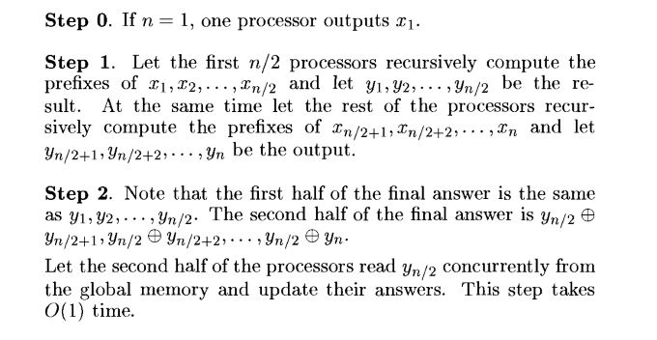
Algorithm 2: Work-Optimal Logarithmic Time Prefix Computation.
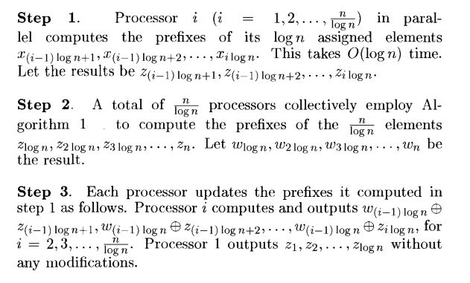

We present a CREW PRAM algorithm that uses n/logn processors and runs in O(logn) time. The work done by such an algorithm is O(n) and hence the algorithm has an efficiency of theta(1) and is work-optimal. Also, the speed up of this algorithm is theta(n/logn). We employ the divide-and-conquer strategy to devise the prefix algorithm. Let the input be x1,x2,…, xn. Without loss of generality assume that n is an integral power of 2. We first present an n-processor and O(logn) time algorithm (Algorithm 1).

Time Complexity of Algorithm 1:
Let T(n) be the runtime of Algorithm 1 on any input of size n using n processors. Step 1 takes T(n/2) time and step2 takes O(1) time.
So, we get the following recurrence relation for T(n): T(n) = t(n/2)+O(1), T(1)= 1
This solves to T{n) = O(logn). The run time of a parallel divide-and-conquer algorithm, it is essential to quantify it with the number of processors used. Algorithm 1is not work-optimal for the prefix computation problem since the total work done by this algorithm is theta(nlogn), whereas the run time of the best-known sequential algorithm is theta(n). A work-optimal algorithm can be obtained by decreasing the number of processors used to n/logn, while keeping the asymptotic run time the same. The number of processors used can be decreased to n/logn as follows.
We first reduce the number of inputs to n/logn, apply the non-work-optimal Algorithm 1 to compute the prefixes of the reduced input, and then finally compute all the n prefixes. Every processor will be in charge of computing logn final answers. If the input is x1,x2,…,xn and the output is y1,y2…,yn, let processor i be in charge of the outputs y(i-1)logn+i, y(i-1)logn+2, ..., i logn, for i = 1,2,..., n/logn. The detailed algorithm appears as Algorithm 2. The correctness of the algorithm is clear. Step1 takes O(logn) time. Step2 takes O(log(n/logn)) = O(logn) time (using Algorithm1). Finally, step3 also takes O(logn) time. Thus we get the following theorem.
Prefix computation on an n-element input can be performed in O(logn) time using^\342\200\22 n/logn CREW PRAM processors.

- a) Specify the implicit and explicit constraints that are required to solve the following problems using backtracking strategy:
- 8-Queens
- Sum of Subsets
- 0/1 Knapsack
- Graph Colouring
- Hamiltonian Cycle
- Ans- 8-Queens
Explicit Constraints: The solution space consists of 8-tuples.
Implicit Constraints: No two queens can be on the same row, column or diagonall.

- Sum of Subsets
Explicit Constraints: The elements X(i) of the solution vector is either 1 or 0 depending on if the weight W(i) is included or not.
Implicit Constraints: In the 1-neighbour knapsack problem, an item can be selected only if at least one of its neighbours is also selected.

- 0/1 Knapsack
Explicit Constraints: the 0/1 knapsack problem calls for choosing a subset of the weights such that
S _{i = 1 to k} w_{i}x_{i} £ M and
S _{i = 1 to k} p_{i}x_{i} is maximizd
The x's constitute a zero-one valued vector. The solution space for this problen consists of the 2^{n} distinct ways to assign zero or one values to the x's.
Implicit Constraints: A good bounding function for this problem is obtained by using an upper bound on the value of the best feasible solution obtainable by expanding the given live node and any of its descendants. If this upper bound is not higher than the value of the best solution determined so far then that live node may be killed. Here we use the fixed tuple size formulation. If at node Z the values of x_{i} , 1 £ i £ k have already been determined, then an upper bound for Z can be obtained by relaxing the requirement x_{i} = 0 or 1 to 0 £ x_{i} £ 1 for k+1 £ i £ n and use the greedy method to solve the relaxed problem.

- Graph Colouring
Explicit Constraints: The output array x[1..n] is solution for the given problem.
Implicit Constraints: The color information is stored in array “x”
Hence G[k,j] != 0 and x[k] = x[j] then color is not suitable otherwise suitable.

- Hamiltonian Cycle
Explicit Constraints: It is a cycle generated on graph, with same vertex as source and destination.
Implicit Constraints: • Each vertex has to be visited once
• Any edge can be used only once
• Some of the edges can be skipped, but vertices cannot be skipped.

b) Write the non-deterministic algorithm for the clique decision problem.
Ans-
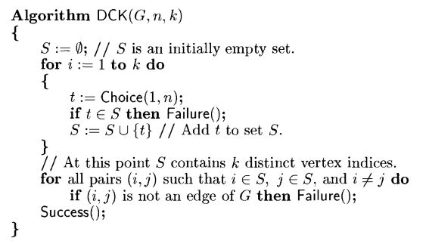

c) Discuss the set-covering problem and its solution.
Ans- It is an optimization problem that models many resource-selection problems. It generalizes the NP-complete vertex-cover problem and is therefore also NP-hard. An instance (X,F) of the set covering problem consists of a finite set X and a family F of subsets of X, such that every element of X belongs to at least one subset in F:
X=$\bigcup_{S∈F}{S}$
We say that a subset SЄF covers its elements. The problem is to find a minimum-size subset C ⊆ F whose members cover all of X:
X=$\bigcup_{S∈C}{S}$
We say that any C satisfying this equation covers X.
Working: The Set U contains at each stage the set of remaining uncovered elements. The set C contains the cover being constructed. The do step is the greedy decision-making step. A subset S is chosen that covers as many uncovered elements as possible. After S is selected, its elements are removed from U, and S is places in C. When the algorithm terminates, the set C contains a subfamily of F that covers X.
Algorithm: GREEDY-SET-COVER(X,F)
U<-X
C<-ф
while U≠ф
do select an S Є F that maximizes |S ∩ U|
U<-U-S
C<-C ∪ {S}
return C

